Implemented GitOps-driven progressive delivery using ArgoCD and Argo Rollouts. Designed both Canary and Blue/Green deployment strategies, enabling safe configuration-based releases through ConfigMap checksum annotations without rebuilding container images
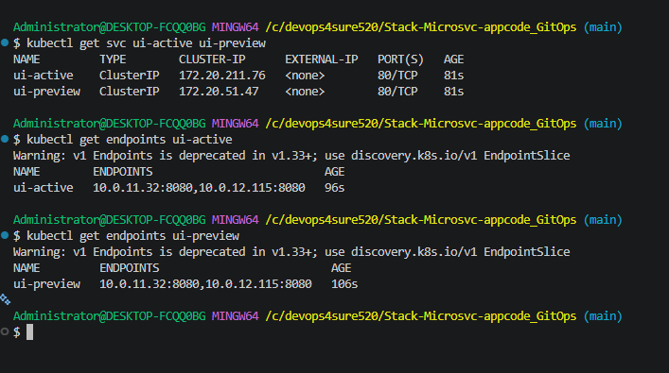
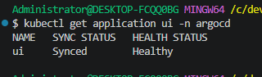
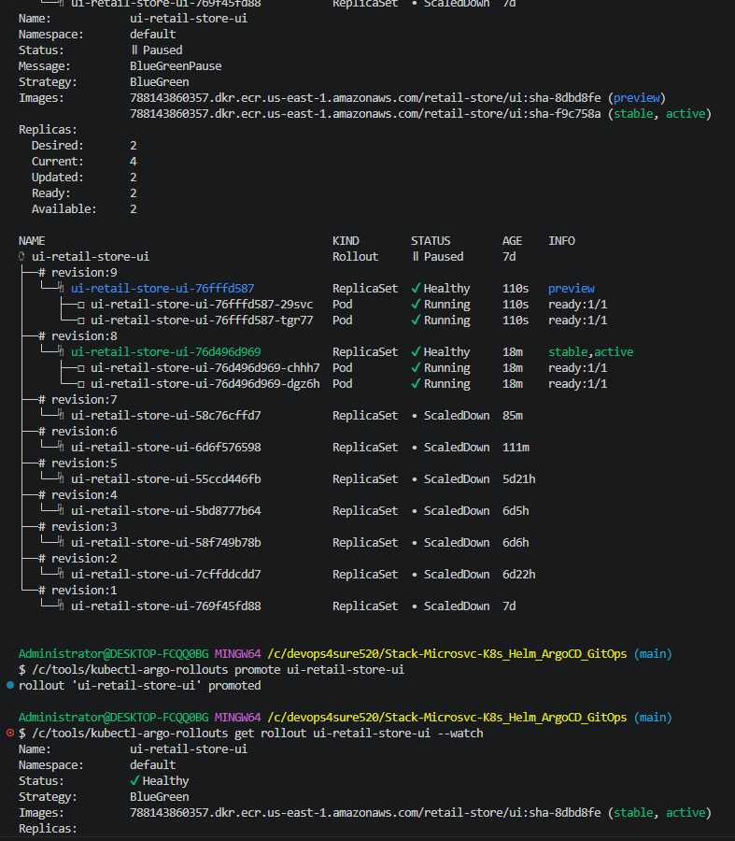
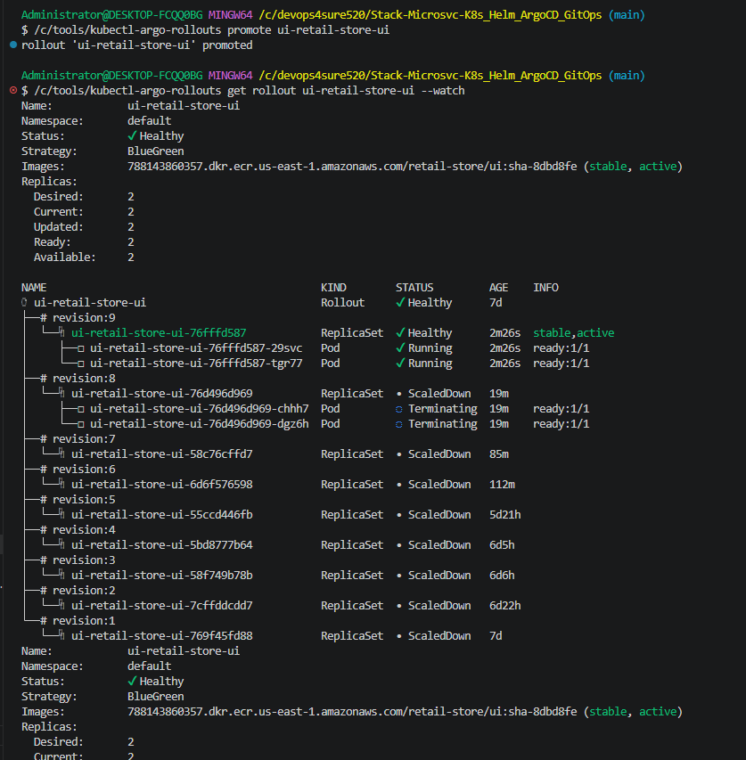
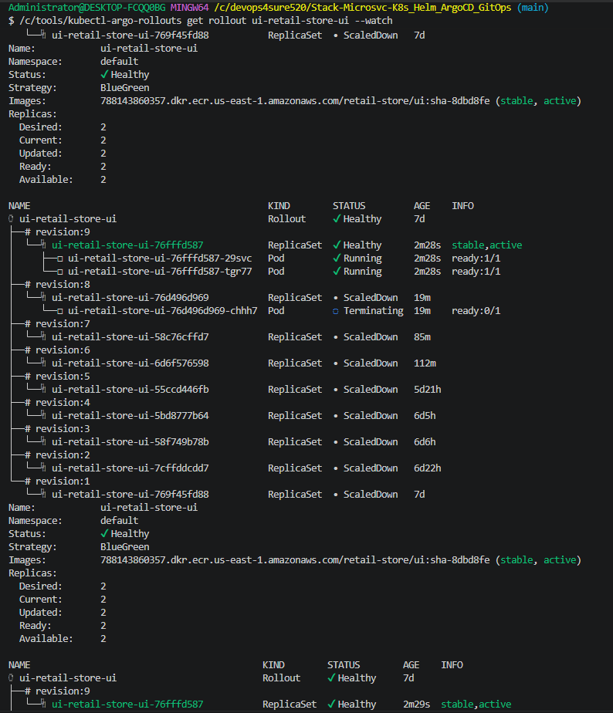
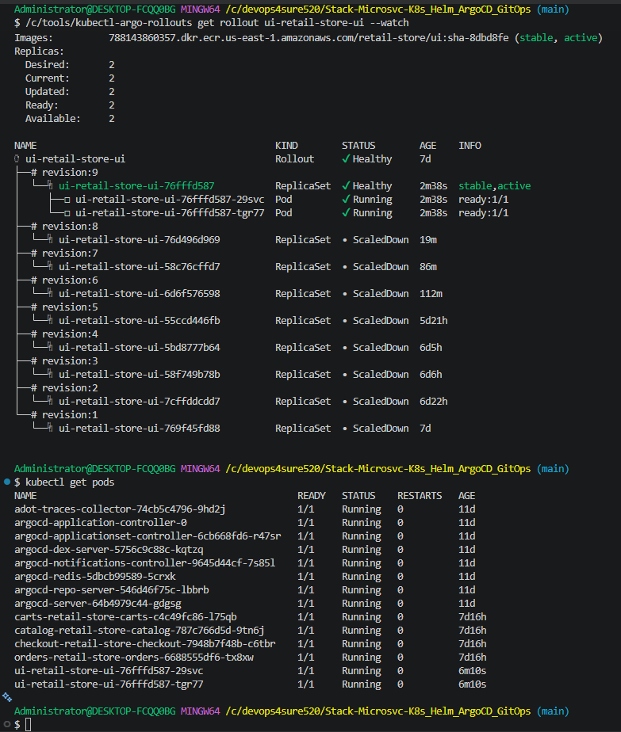


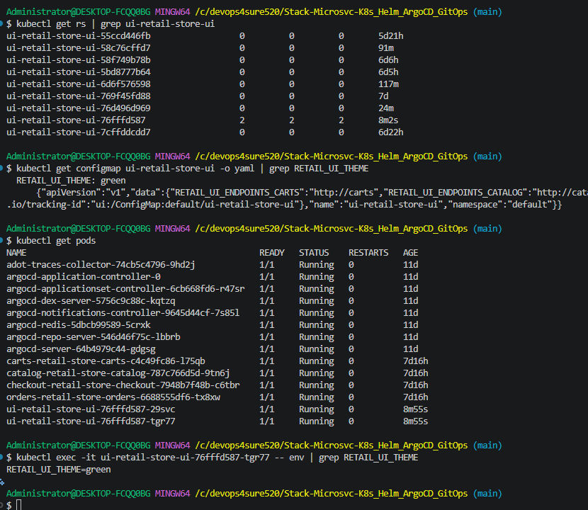
GitOps pipeline succeed
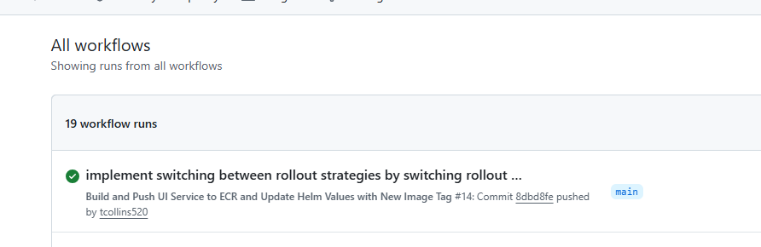
Image tagged and pushed to ECR:
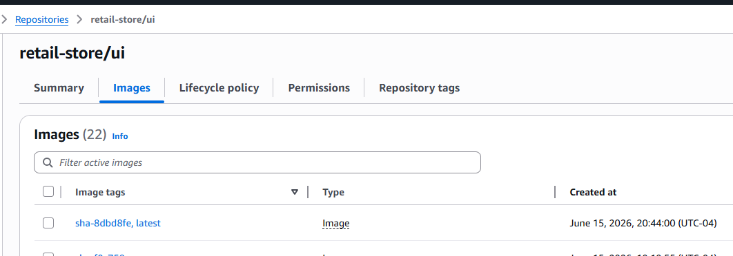
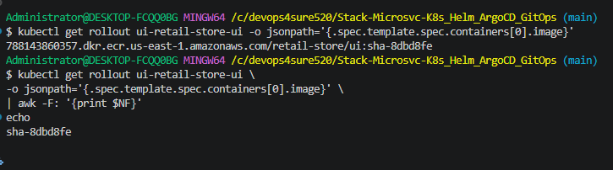
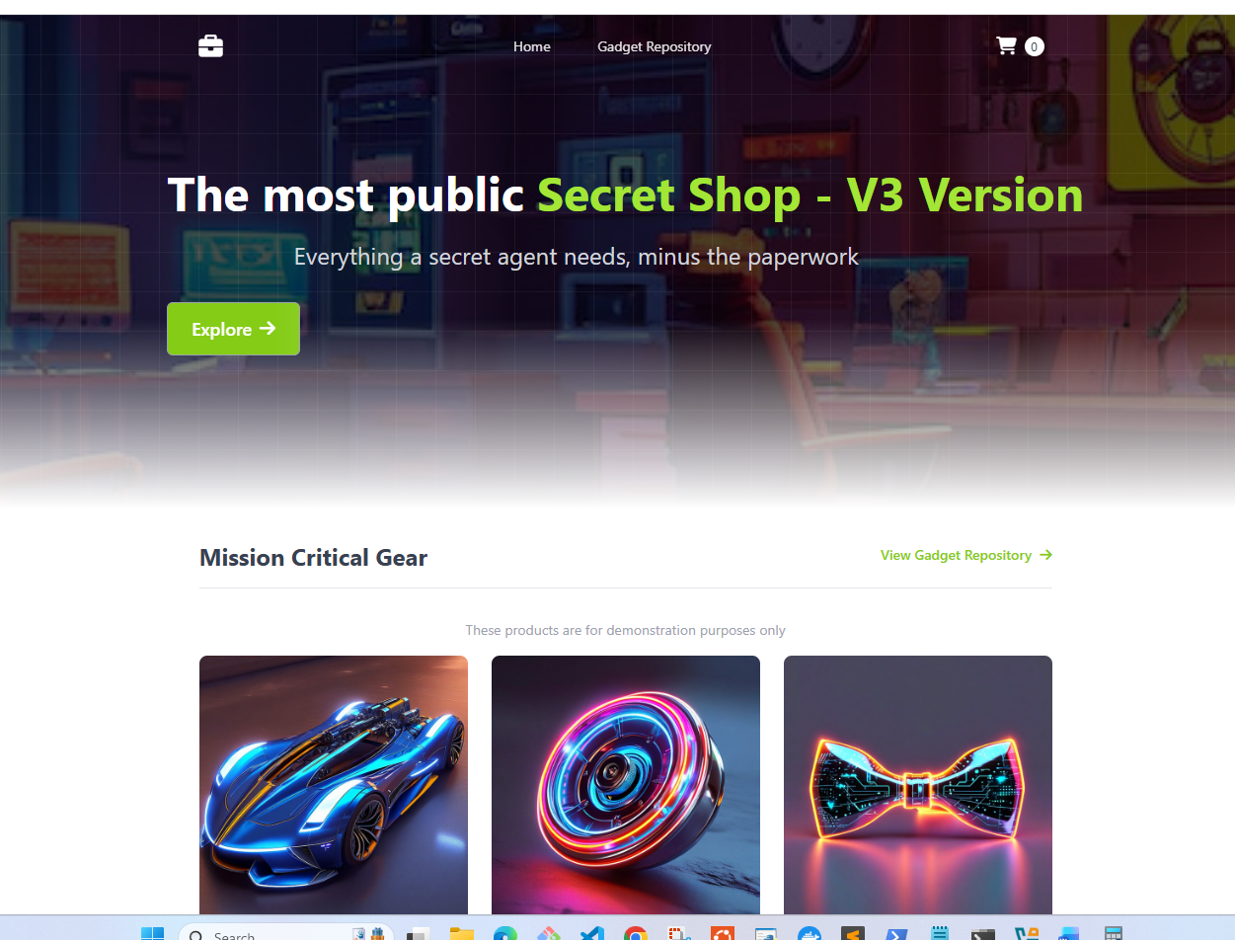
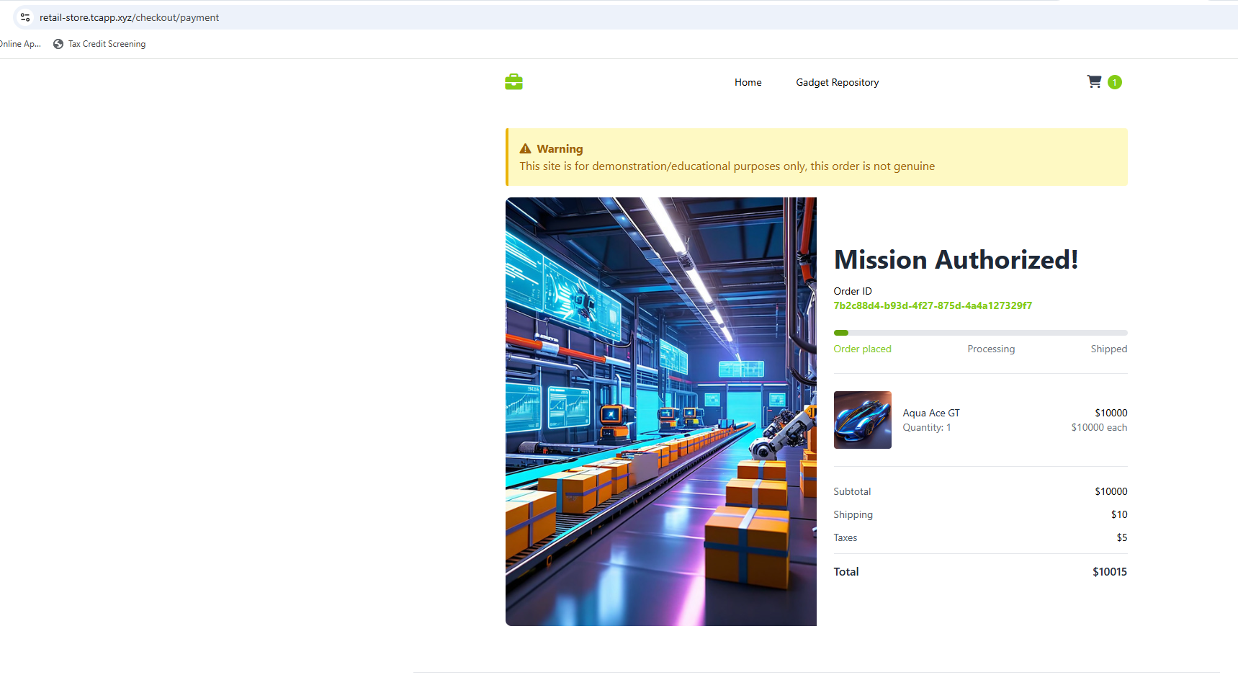
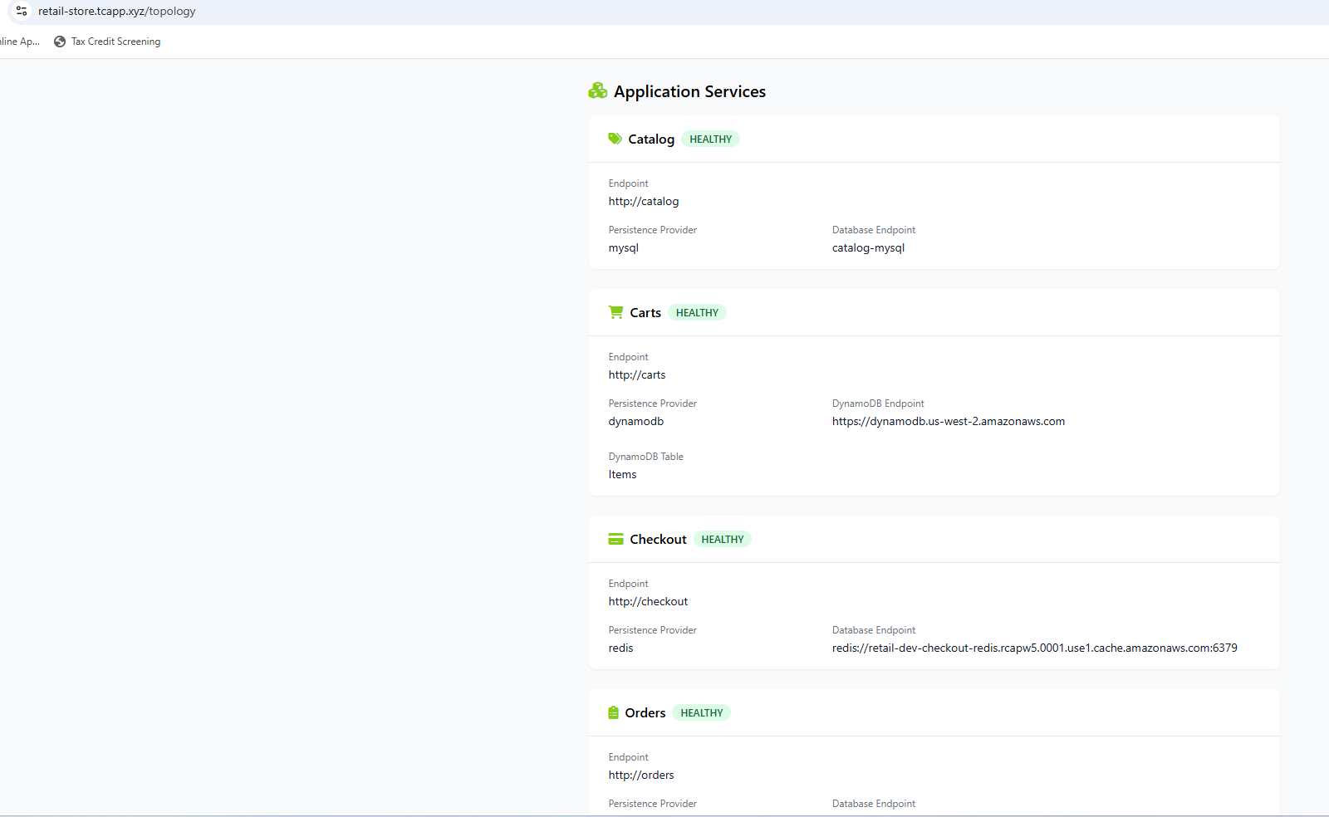

Administrator@DESKTOP-FCQQ0BG MINGW64 /c/devops4sure520/Stack-Microsvc-K8s_Helm_ArgoCD_GitOps (main)
$ kubectl describe rollout ui-retail-store-ui
Name: ui-retail-store-ui
Namespace: default
Labels: app.kubernetes.io/instance=ui
app.kubernetes.io/managed-by=Helm
app.kubernetes.io/name=retail-store-ui
app.kubernetes.io/version=1.16.0
helm.sh/chart=retail-store-ui-0.1.0
Annotations: argocd.argoproj.io/tracking-id: ui:argoproj.io/Rollout:default/ui-retail-store-ui
rollout.argoproj.io/revision: 9
API Version: argoproj.io/v1alpha1
Kind: Rollout
Metadata:
Creation Timestamp: 2026-06-09T00:26:44Z
Generation: 17
Resource Version: 6865851
UID: bf4675c6-752f-4283-9ee8-1f4841bc318b
Spec:
Replicas: 2
Selector:
Match Labels:
app.kubernetes.io/instance: ui
app.kubernetes.io/name: retail-store-ui
Strategy:
Blue Green:
Active Service: ui-active
Auto Promotion Enabled: false
Preview Service: ui-preview
Template:
Metadata:
Annotations:
checksum/config: f39a1cbd3fe521aaf39a23475df444c77c6f647c30c4f89fecaeca88fc4fc3fe
instrumentation.opentelemetry.io/inject-sdk: default-instrumentation
Labels:
app.kubernetes.io/instance: ui
app.kubernetes.io/name: retail-store-ui
Spec:
Containers:
Env From:
Config Map Ref:
Name: ui-retail-store-ui
Image: 788143860357.dkr.ecr.us-east-1.amazonaws.com/retail-store/ui:sha-8dbd8fe
Image Pull Policy: IfNotPresent
Liveness Probe:
Http Get:
Path: /actuator/health/liveness
Port: 8080
Initial Delay Seconds: 30
Period Seconds: 10
Name: ui-retail-store-ui
Ports:
Container Port: 8080
Name: http
Protocol: TCP
Readiness Probe:
Http Get:
Path: /actuator/health/readiness
Port: 8080
Initial Delay Seconds: 10
Period Seconds: 5
Resources:
Limits:
Cpu: 512m
Memory: 1Gi
Requests:
Cpu: 256m
Memory: 512Mi
Security Context:
Allow Privilege Escalation: false
Capabilities:
Drop:
ALL
Read Only Root Filesystem: true
Run As Non Root: true
Run As User: 1000
Seccomp Profile:
Type: RuntimeDefault
Startup Probe:
Failure Threshold: 60
Http Get:
Path: /actuator/health/readiness
Port: 8080
Period Seconds: 10
Volume Mounts:
Mount Path: /tmp
Name: tmp-volume
Node Selector:
karpenter.sh/capacity-type: spot
Security Context:
Fs Group: 1000
Service Account Name: ui
Termination Grace Period Seconds: 30
Topology Spread Constraints:
Label Selector:
Match Labels:
app.kubernetes.io/component: service
app.kubernetes.io/instance: ui
app.kubernetes.io/name: ui
Max Skew: 1
Topology Key: kubernetes.io/hostname
When Unsatisfiable: ScheduleAnyway
Label Selector:
Match Labels:
app.kubernetes.io/component: service
app.kubernetes.io/instance: ui
app.kubernetes.io/name: ui
Max Skew: 1
Topology Key: topology.kubernetes.io/zone
When Unsatisfiable: DoNotSchedule
Volumes:
Empty Dir:
Medium: Memory
Name: tmp-volume
Status:
HPAReplicas: 2
Available Replicas: 2
Blue Green:
Active Selector: 76fffd587
Preview Selector: 76fffd587
Canary:
Conditions:
Last Transition Time: 2026-06-16T00:29:49Z
Last Update Time: 2026-06-16T00:29:49Z
Message: Rollout has minimum availability
Reason: AvailableReason
Status: True
Type: Available
Last Transition Time: 2026-06-16T00:47:22Z
Last Update Time: 2026-06-16T00:47:22Z
Message: Rollout is healthy
Reason: RolloutHealthy
Status: True
Type: Healthy
Last Transition Time: 2026-06-16T00:47:22Z
Last Update Time: 2026-06-16T00:47:22Z
Message: ReplicaSet "ui-retail-store-ui-76fffd587" has successfully progressed.
Reason: NewReplicaSetAvailable
Status: True
Type: Progressing
Last Transition Time: 2026-06-16T00:47:22Z
Last Update Time: 2026-06-16T00:47:22Z
Message: RolloutCompleted
Reason: RolloutCompleted
Status: True
Type: Completed
Last Transition Time: 2026-06-16T00:47:22Z
Last Update Time: 2026-06-16T00:47:22Z
Message: Rollout is paused
Reason: RolloutPaused
Status: False
Type: Paused
Current Pod Hash: 76fffd587
Observed Generation: 17
Phase: Healthy
Ready Replicas: 2
Replicas: 2
Selector: app.kubernetes.io/instance=ui,app.kubernetes.io/name=retail-store-ui,rollouts-pod-template-hash=76fffd587
Stable RS: 76fffd587
Updated Replicas: 2
Events:
Type Reason Age From Message
---- ------ ---- ---- -------
Normal RolloutUpdated 24m rollouts-controller Rollout updated to revision 8
Normal NewReplicaSetCreated 24m rollouts-controller Created ReplicaSet ui-retail-store-ui-76d496d969 (revision 8)
Normal SwitchService 24m rollouts-controller Switched selector for service 'ui-preview' from '' to '76d496d969'
Normal RolloutCompleted 24m rollouts-controller Rollout completed update to revision 8 (76d496d969): Initial deploy
Normal ScalingReplicaSet 24m rollouts-controller Scaled up ReplicaSet ui-retail-store-ui-76d496d969 (revision 8) from 0 to 2
Normal ScalingReplicaSet 23m rollouts-controller Scaled down ReplicaSet ui-retail-store-ui-58c76cffd7 (revision 7) from 2 to 0
Normal SwitchService 23m rollouts-controller Switched selector for service 'ui-active' from '' to '76d496d969'
Normal RolloutUpdated 7m40s rollouts-controller Rollout updated to revision 9
Normal NewReplicaSetCreated 7m40s rollouts-controller Created ReplicaSet ui-retail-store-ui-76fffd587 (revision 9)
Normal SwitchService 7m40s rollouts-controller Switched selector for service 'ui-preview' from '76d496d969' to '76fffd587'
Normal RolloutNotCompleted 7m40s rollouts-controller Rollout not completed, started update to revision 9 (76fffd587)
Normal ScalingReplicaSet 7m40s rollouts-controller Scaled up ReplicaSet ui-retail-store-ui-76fffd587 (revision 9) from 0 to 2
Normal RolloutPaused 6m58s (x3 over 6d5h) rollouts-controller Rollout is paused (BlueGreenPause)
Normal SwitchService 5m44s rollouts-controller Switched selector for service 'ui-active' from '76d496d969' to '76fffd587'
Normal RolloutCompleted 5m44s rollouts-controller Rollout completed update to revision 9 (76fffd587): Completed blue-green update
Normal ScalingReplicaSet 5m14s rollouts-controller Scaled down ReplicaSet ui-retail-store-ui-76d496d969 (revision 8) from 2 to 0

